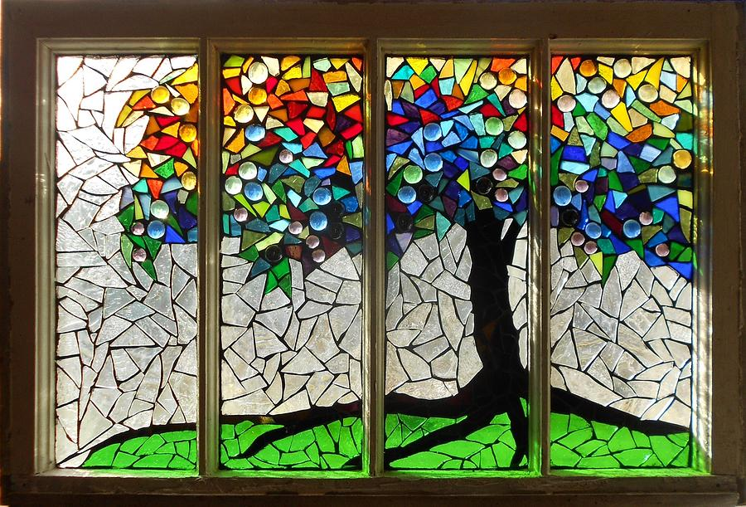
Mixed Media
Glass Mosaic Project | Term One

Step-by-Step Guidelines

Things to look out for:

- SCALE- Consistency and (Small) Size
Are your pieces approximately the same size?
If they are changing in size, is it intentional?
- COLOR- Complementary or Analogous?
What is the color scheme of your composition?

How do you begin?

- Make three thumbnail sketches
- Commit to one good thumbnail sketch and enlarge it onto a larger piece of paper
- Transfer the drawing onto the piece of board using tracing paper
- Optional: Retrieve glasses and gloves
- Claim a piece of Brown Board, Glass*, Bucket, and Chipper
- *Select enough glass to cover your designed surface area
- Start chipping your glass into the bucket
- Use those pieces to outline the subject AND border first by gluing them down, then fill in the subject
- Fill in the background
- Grout your almost-finished piece!
- Let it dry for the next class
- Sand down and Voila!

Theme of your Glass Mosaic:
My Favorite…
When an artist works on a mosaic, they are forced to slow down and appreciate the small details in the piece, in order to create a beautiful large composition. In order to parallel the medium we are using, we will slow down and choose to replicate an image of something that we love, cherish, or admire. For example, your glass mosaic may be of a symbol to represent someone you admire, an image of a landscape of a place that you enjoy visiting, or it may be something abstract and representative of a song that tugs your heart-strings. There is no “right” answer to this project in terms of theme and composition, but what needs to be carefully considered is your attention to detail while drawing, cutting, and gluing your glass pieces down (craftsmanship).

Safety:
- Never throw out glass in the trash, always into our glass-recycling bin.
- Glasses and Gloves are ALWAYS available to you on top of counter by the white board.
- Always Chip into a Bucket.
- Always wash hands before you leave the classroom, especially before you eat!
- No food or drink in the classroom.
- Listen for instructions from teacher.

